**Business Requirements Document: Projects & Inspiration** April 16, 2020

**OBJECTIVE**

To provide a differentiated customer experience through project tutorials, trend spotlights and educational articles that inspire project ideas, instill sewing confidence and guides selection decisions for the right materials to complete. This space is intended to be a maker’s playground and a resource for educational content. Our content should be centralized and easy to find onsite, enabling customers to explore our catalog of projects, inspiration, and education by project type. This content should also be structured to enable external discoverability of specific projects/articles providing navigational pathways to the broader project experience.

To implement projects for Fabric.com, we have three main goals we would like to accomplish:

1. Provide internal user functionality to create projects through a cloudCMS editorial process,
2. Create new customer-facing inspiration templates on the website, and
3. Enhance customer discoverability both through SEO as well as onsite navigation

Project visuals for these components are available [here](https://xd.adobe.com/view/8c007e9d-66b8-4034-539a-cdf1ab149b6f-fa31/screen/016020a0-2bd9-4b09-b938-5c55b11870de/iPhone-X-XS-11-Pro-5), as well as the appendix.

**PRIMARY USER STORY**

AS A customer who wants to make something special but isn’t sure where to start, I WANT TO know that fabric.com is a trusted destination to be inspired by project ideas, reference clear instructions, and enable me to purchase a bundle of recommended fabrics SO THAT I can flex my maker skills and create something awesome.

|  |  |
| --- | --- |
| **Definition of Priorities** | |
| P0 | Must have |
| P1 | Fast follow |
| P2 | Nice to have; future enhancement |
| MLP | Minimal Lovable Product |
| **Type of Requirement** | |
| New | Needs new development |
| Re-do | Functionality exists today but cannot be used as is. Will need to be re-coded |
| Tweak | Needs some dev work but mostly tweaking existing functionality |
| No-op | (No-op = No operation) Does not need additional dev work but may require business team configuration |

**For Reference:**

* ILP = Inspiration Listing Page
* IDP = Inspiration Detail Page

**CONTENT CREATION**

|  |  |  |  |  |  |
| --- | --- | --- | --- | --- | --- |
| **Team** | **ID** | **Requirement** | **On Site?** | **Priority** | **Type** |
| Fabric Tech | A | **Page Template Type:** determines available module options and configurations needed:   * Inspiration Detail Page (IDP) * Inspiration / Trends * Education / Sewing 101 | Yes | P0/MLP | New |
| Fabric Tech | B | **Project Components** (Elements of a Project)   * Media (Main Image and Alt Images) * Time to Completion (Duration) * Project Difficulty * Project Name/Title * Contributor Attribution * Ratings & Reviews * Project Description * Project Guide (anchor links on page) * Materials Needed (Associated Products) * Step by Step * Gather Your Materials * Measuring & Cutting * Pulling It Together * Finishing Details * Project Price and potential bundle discount * Season/Holiday and any related branding * Subcategory or Tag and any related branding * Images / video * Downloadable pattern (PDF) * Print tutorial (PDF) | Yes | P0/MLP | New |
| Fabric Tech | C | **Bazaarvoice Integration**   * Ratings and reviews displayed on the page   **\*\*Technical investigation needed\*\*** | Yes | P0/MLP | New |
| Cloud CMS/Content Creator | D | **cloudCMS Project Creation Process**   * Create project * Project Name/Title * Project description * Generate Project ID Unique Page ID (Similar to SKU identifier) for each project page * Incorporate contributor attribution (Contributor name, email, URL, +social attribution options) * Define project category to determine where the articles will live: Quilt, Apparel, Home Decor * Define project attributes   + Project type: Project, Trend Spotlight, Sewing 101 Education)   + Project difficulty: easy, intermediate, advanced, kid friendly   + Season/holiday: Fall, Holiday, Easter, St. Patrick’s Day etc.   + Subcategory or Tag: enables greater refinement by sub-category i.e. Dresses within Apparel, or Curtains within Home Décor   + Project Discount %   + Time to Completion (Duration)   **cloudCMS Media & Content** (elements may vary by project type)   * Images / video (YouTube) * Suggested Materials (to SKUs or PLPs) * Gather Your Materials * Measuring & Cutting * Pulling it Together (step by step instructions) * Finishing Details * Downloadable pattern (PDF) * Print Tutorial (PDF) | Yes | P0/MLP | New |
| Fabric Tech | E | **Fabric Tech Integration in to cloudCMS Components**   * Suggested Materials (Products) * Pricing * Add to Cart functionality * Acoustics tagging * Project Share to Pinterest, Facebook or email   **\*\*Technical investigation needed\*\*** | Yes | P0/MLP | New |
| Fabric Tech | F | **Dynamic ILP Generation**  Categories and subcategories will generate their own ILPs for external keyword discoverability (quilt category will generate a quilt ILP) | Yes | P0/MLP | New |
| Cloud CMS | G | **Social Tagging**  Add associated tags for social sharing and hashtags | Yes | P0/MLP | New |
| Cloud CMS | H | **Project Status**  Ability to define status (i.e. active, inactive) | Yes | P0/MLP | New |
| Cloud CMS/FT | I | **Define Creation Date**  Date project is created in the system | Yes | P0/MLP | New |
| Cloud CMS/FT | J | **Set Launch Date**  Set a date in the future for customer availability | No | P0/MLP | New |
| Cloud CMS/FT | K | **Set Expiration Date** (if applicable)  Set a date when a published page is no longer visible on the site. If page expires, customer should be redirected to ILP for the primary category type (i.e. quilt, apparel) | No | P0/MLP | New |
| Cloud CMS | L | **Ability To Search**  Find an existing project | No | P0/MLP | New |
| Cloud CMS | M | **Ability To Edit, Preview and Publish**  Once a project is located, the ability to make edits | No | P0/MLP | New |
| Cloud CMS/FT | N | **Generate Meta Data** (see SEO section) | Yes | P0/MLP | New |
| Fabric Tech | O | **Data Migration**  Migrate all project content and published assets (video/images/PDFs) (approx. 100 articles) from the existing Ghost blog to Cloud CMS.   * Publish to new URL structure   Set up redirects for all migrated project blog content to point to new URL. | Yes | P0/MLP | New |
| Fabric Tech | P | **Render Project components on site** (match UX visuals)   * Media (Main Image and Alt Images) * Time to Completion (Duration) * Project Difficulty * Project Name/Title * Contributor Attribution * Ratings & Reviews * Project Description * Project Guide (anchor links on page) * Materials Needed (Associated Products) * Step by Step * Gather Your Materials * Measuring & Cutting * Pulling It Together * Finishing Details * Project Price and potential bundle discount * Season/Holiday and any related branding * Subcategory or Tag and any related branding * Images / video * Downloadable pattern (PDF) * Print tutorial (PDF) | Yes | P0/MLP | New |

**DISCOVERABILITY**

|  |  |  |  |  |
| --- | --- | --- | --- | --- |
| **Team** | **ID** | **Requirement** | **Priority** | **Type** |
| Fabric Tech | A | **Taxonomy Structure**  Tagging structure that supports grouped product pages. This enables customers to navigate the assortment of projects (similar to Product List Page).   * Drive discoverability and customer experience by category generated project * ILPs leveraging defined category grouping (Quilt, Apparel, Home Décor) * Additional filter and grouping based on subcategory or tag * Leverage left hand navigation refinements based on categories, subcategories and tags   Need to limit manual processes for generating ILP for Merchandising/Marketing teams  **\*\*Technical investigation needed\*\*** | P0/MLP | New |
| Fabric Tech | B | **Slug/URL** (see SEO section) | P0/MLP | New |
| Fabric Tech | C | **Mega Nav**  Incorporate exposure within the Mega Nav | P0/MLP | New |
| Fabric Tech | D | **Inspiration Display Page (IDP)**  Generate project landing page, with curated navigation to ILP. This could be static for P0.  Build static pages in CMS or Admin to publish curated ILP pages. Content Creator must be able to add a Project Title, Image, Link at minimum for each Project on the landing page.  **\*\*Technical investigation needed\*\*** | P0/MLP | New |

**SEARCH ENGINE OPTIMIZATION**

|  |  |  |  |  |
| --- | --- | --- | --- | --- |
| **Team** | **ID** | **Requirement** | **Priority** | **Type** |
| Fabric Tech | A | **Meta Data**  **IDP URL/Slug** (Google uses webpage URL to understand content)   * URL slug should be the name/title of the project * All projects will be in /project-inspiration/ sub folder * Example: here   ILP Slug/URL structure should support the page type (Category= Quilt, Subcategory= Quilt Blocks, IDP= holiday mini blocks)   * Category ILP  Example: fabric.com/project-inspiration/quilt projects & inspiration * Subcategory ILP  Example: fabric.com/project-inspiration/quilt blocks   **Title Tag** (provides high-level overview of what your page is about)   * 68 characters max * Should be title of project * Example: Project Title | Fabric.com (How To Sew a Throw Pillow Easy Guide | Fabric.com   **Meta Description** (Helps your result stand out and can boost organic CTR)   * 155 characters max * Example: CTA + Content Overview + Specific Benefit/Value + Content Description (Learn how to sew your own decorative throw pillow just in time for fall and couch time. This step-by-step throw pillow tutorial is great for all sewing levels).   **H1 Tag** (Helps Google understand the structure of the page)   * Use project as title in H1 * Example: Project Title (Holiday Mini Quilt Block Tutorial)   **H2 Tag** (Helps signal topical relevance and page structure)   * Wrap section headings in H2 tags * Example: Subheadings (Tools and Supplies)   **H3 Tag** (Helps signal topical relevance and page structure)   * Wrap subheadings in H3 tags, such as tutorial steps * Example: Tutorial Steps (Step 1: Measure & cut the fabric) | P0/MLP | New |
|  | B | **Rich Media – Image Alt Tags**  Image Alt Tags (boost ranking potential in web and image search results, allow search bots and those who are visually impaired to better understand content of images)   * Ensure all images have keyword-rich, descriptive image alt tags * 100 characters max   **\*\*Technical investigation needed\*\*** |  |  |
| Fabric Tech | C | **Rich Media – Video XML Sitemap & Schema**  Allows search engines to easily find and better understand on-page videos   * Create video XML sitemap * Implement video schema markup for various project videos   **\*\*Technical investigation needed\*\*** |  |  |
| Fabric Tech | D | **Rich Media - Video Transcript**  With appropriate HTML markup, transcripts increase chances to rank for rich results or in video results page. Also provide alternative for users who prefer to read instructions)   * Utilize video transcripts and leverage descriptive supporting text on each landing page   **\*\*Technical investigation needed\*\*** |  |  |
| Fabric  Tech | E | **Rich Media - Ratings / Review Schema**  Improve crawlers’ understanding of on-page content and increase opportunity to rank for rich snippets and stand out amongst other results   * Implement review schema markup for various project videos   **\*\*Technical investigation needed\*\*** |  |  |

**REPORTING**

|  |  |  |  |  |
| --- | --- | --- | --- | --- |
| **Team** | **ID** | **Requirement** | **Priority** | **Type** |
| Data Tech | A | Exceptions reporting for out of stock and low stock products (use PDP logic for out of stock and limited quantity messaging). | P0/MLP | New |
| Data Tech | B | Implement Acoustic tagging requirements for new page types | P0/MLP | New |

**PROJECT BUNDLES**

|  |  |  |  |  |
| --- | --- | --- | --- | --- |
| **Team** | **ID** | **Requirement** | **Priority** | **Type** |
| Fabric Tech | A | Ability to add all project components to cart | P0/MLP | New |
| Fabric Tech | TBD | Enable the ability to select SKU groupings incorporating cut length and define as a project bundle | **P1** | New |
| Fabric Tech | TBD | Ability to auto generate backup replacements if an item is sold out | **P1** | New |
| Fabric Tech | TBD | Ability for customers to select alternate pattern replacements for project items and add to cart within the same experience. | **P1** | New |

**RELATED PROJECTS**

|  |  |  |  |  |
| --- | --- | --- | --- | --- |
| **Team** | **ID** | **Requirement** | **Priority** | **Type** |
| Fabric Tech | TBD | Link and display related projects through tagging | **P1** | New |

**OPEN QUESTIONS**

1. If there is seasonal/holiday related branding, does this impact # of templates to be designed? **(Ayana)**
2. What are the Acoustics tagging requirements for this new page type? **(Kristen/Jenna)**
3. Provide updated mock-up of the cloudCMS project entry form + specific drop down / selection requirements. **(Crystal)**
4. Provide more Dynamic ILP generation detail with full list of categories/subcategories, sample flowchart and desired behavior. May require a static solution for P0, as LucidWorks can do more dynamic work in Q3. **(Jenna)**
5. What would the out of stock / low inventory business requirements for reporting? **(Ayana)**
6. For project creation components, which are REQUIRED fields? If something is not required, would you want the component to be suppressed on site? If it is required, would you want end-user to have an alert? **(Ayana)**

**NEXT STEPS**

1. Create and build timeline for technical investigation tickets. Review in Monday “New Ticket Business Justification Review” and “Technical Resource Review” meetings.
2. Build full project plan with cross-functional deliverables and timelines for completion by August 2020.
3. Report findings from technical investigations + project status at weekly Steering Committee.

**APPENDIX**

1. **Projects Flow Chart:**

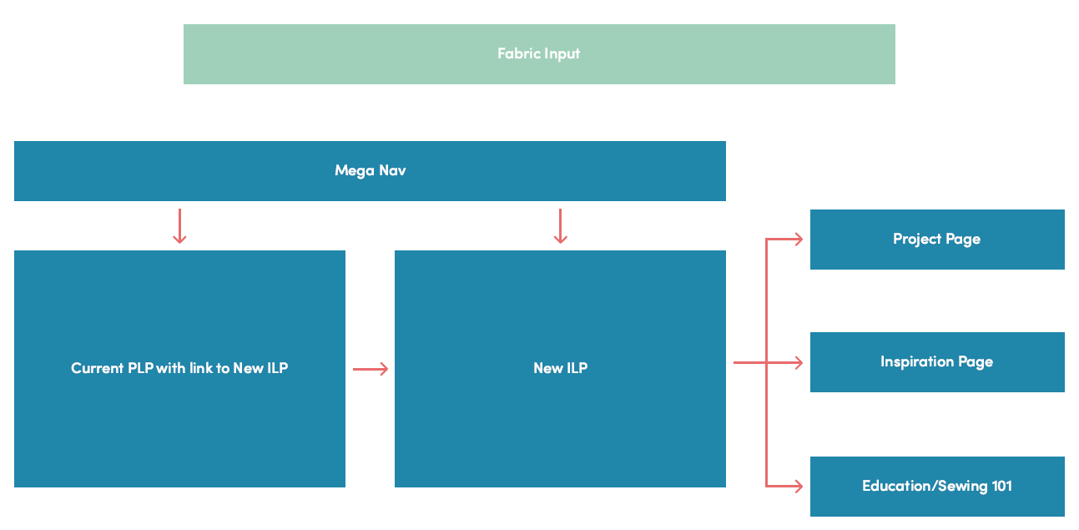

1. **Mock-Ups: Fabric Input / CMS Project Create**

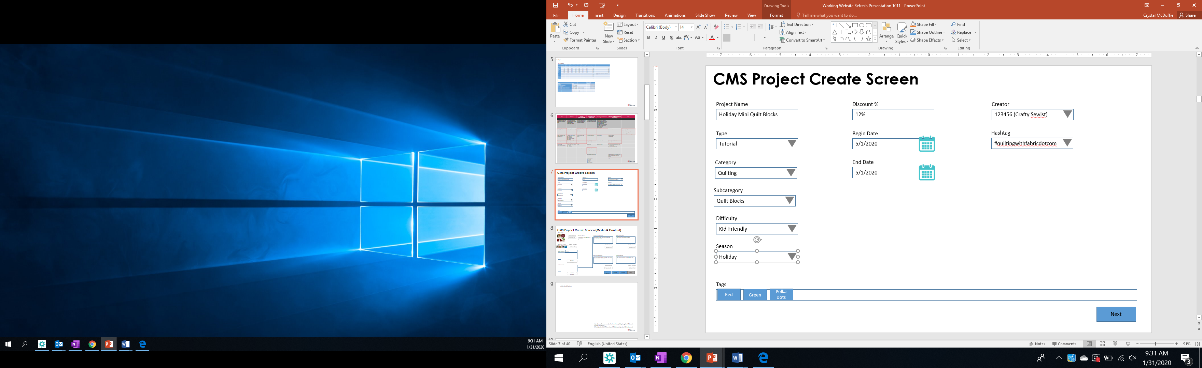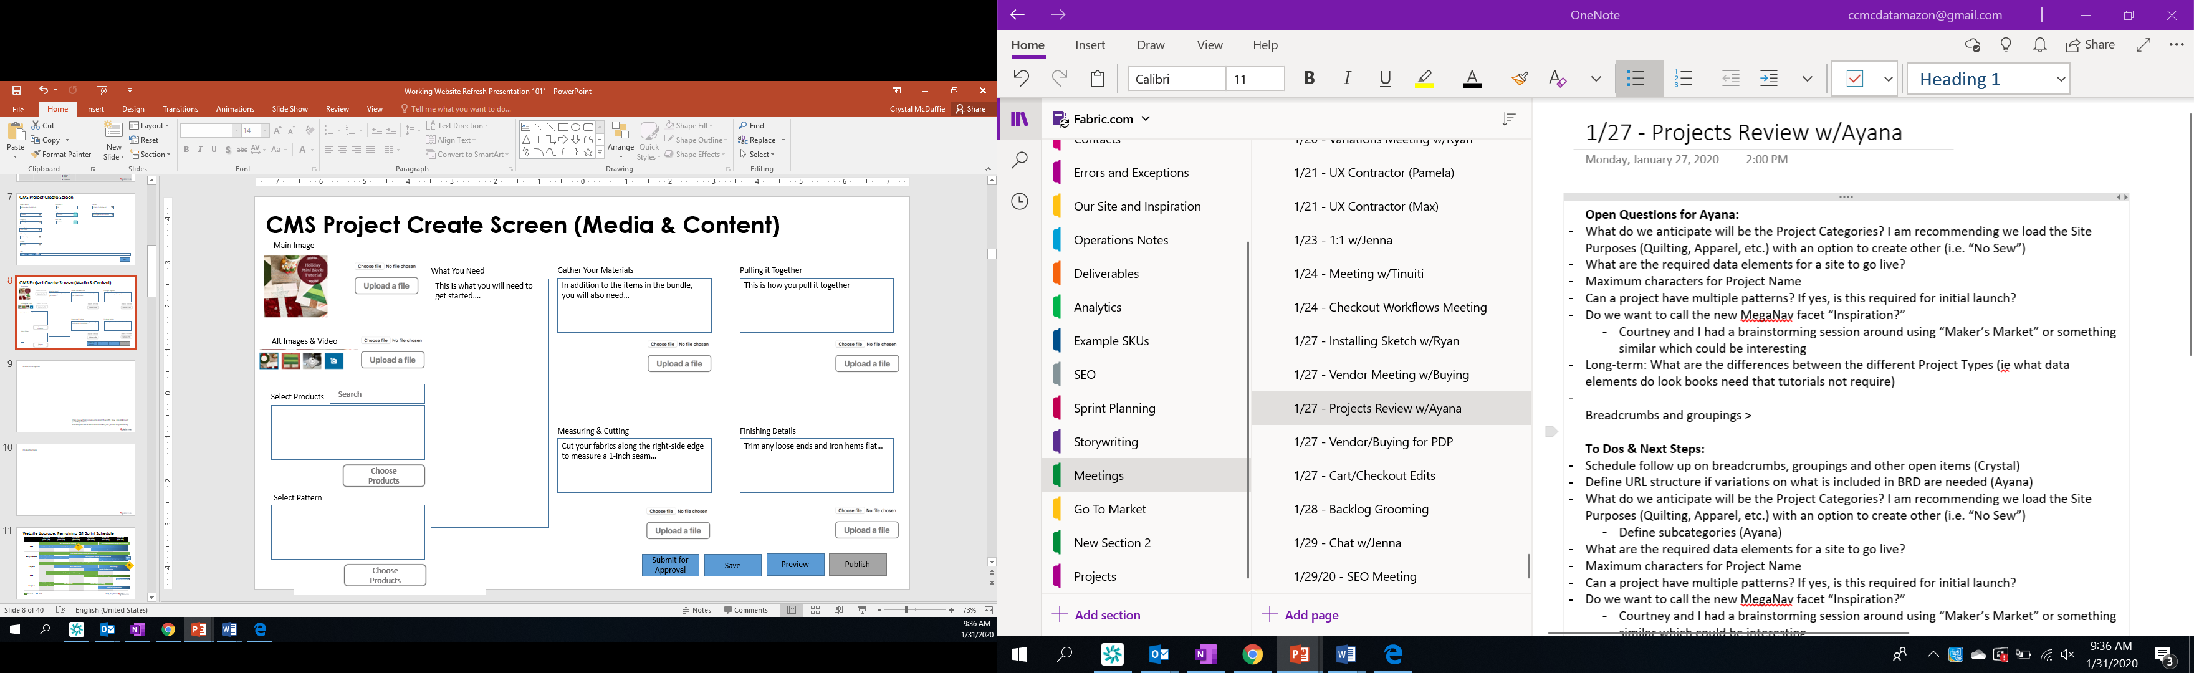

1. **Mock-Ups: Customer Facing Pages**

Digital mock-ups available: [here](https://xd.adobe.com/view/8c007e9d-66b8-4034-539a-cdf1ab149b6f-fa31/screen/016020a0-2bd9-4b09-b938-5c55b11870de/iPhone-X-XS-11-Pro-5).

**Mega-Nav:**

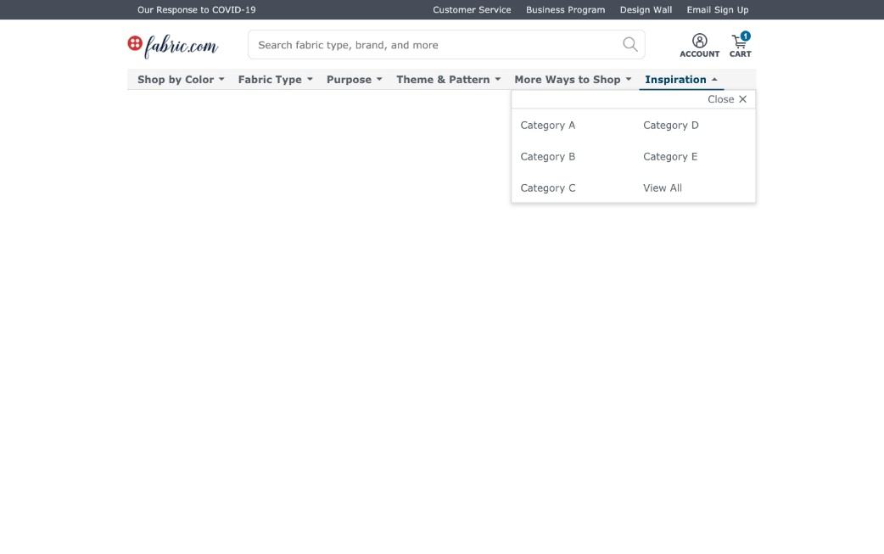

**Inspiration Landing Page:**

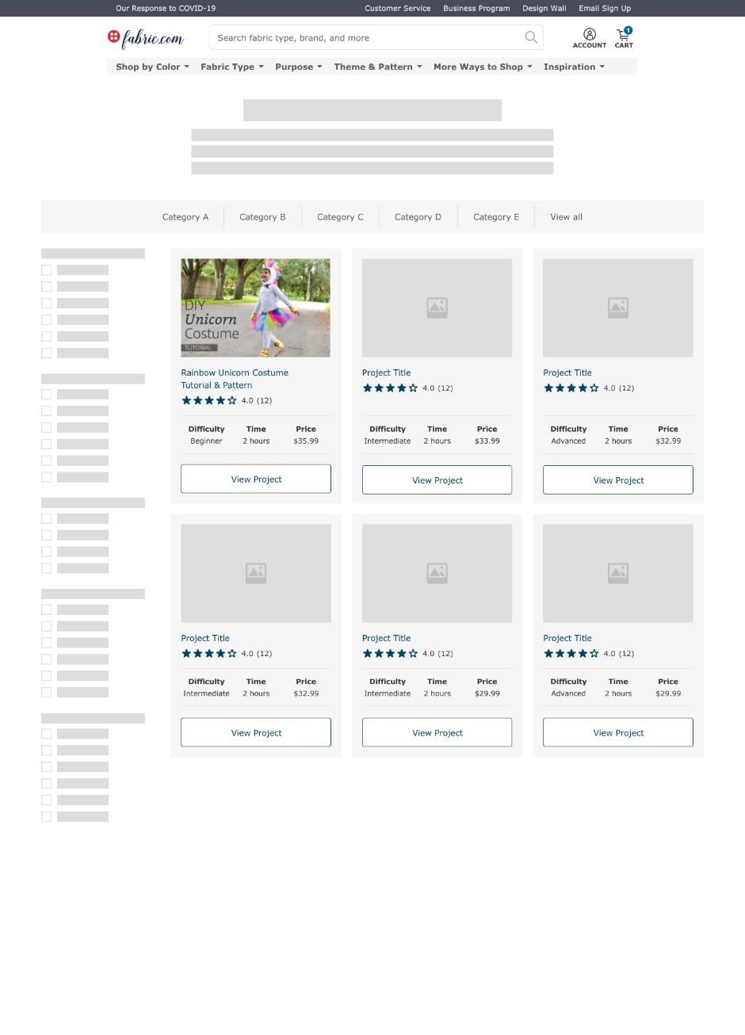

**Inspiration Detail Page:**

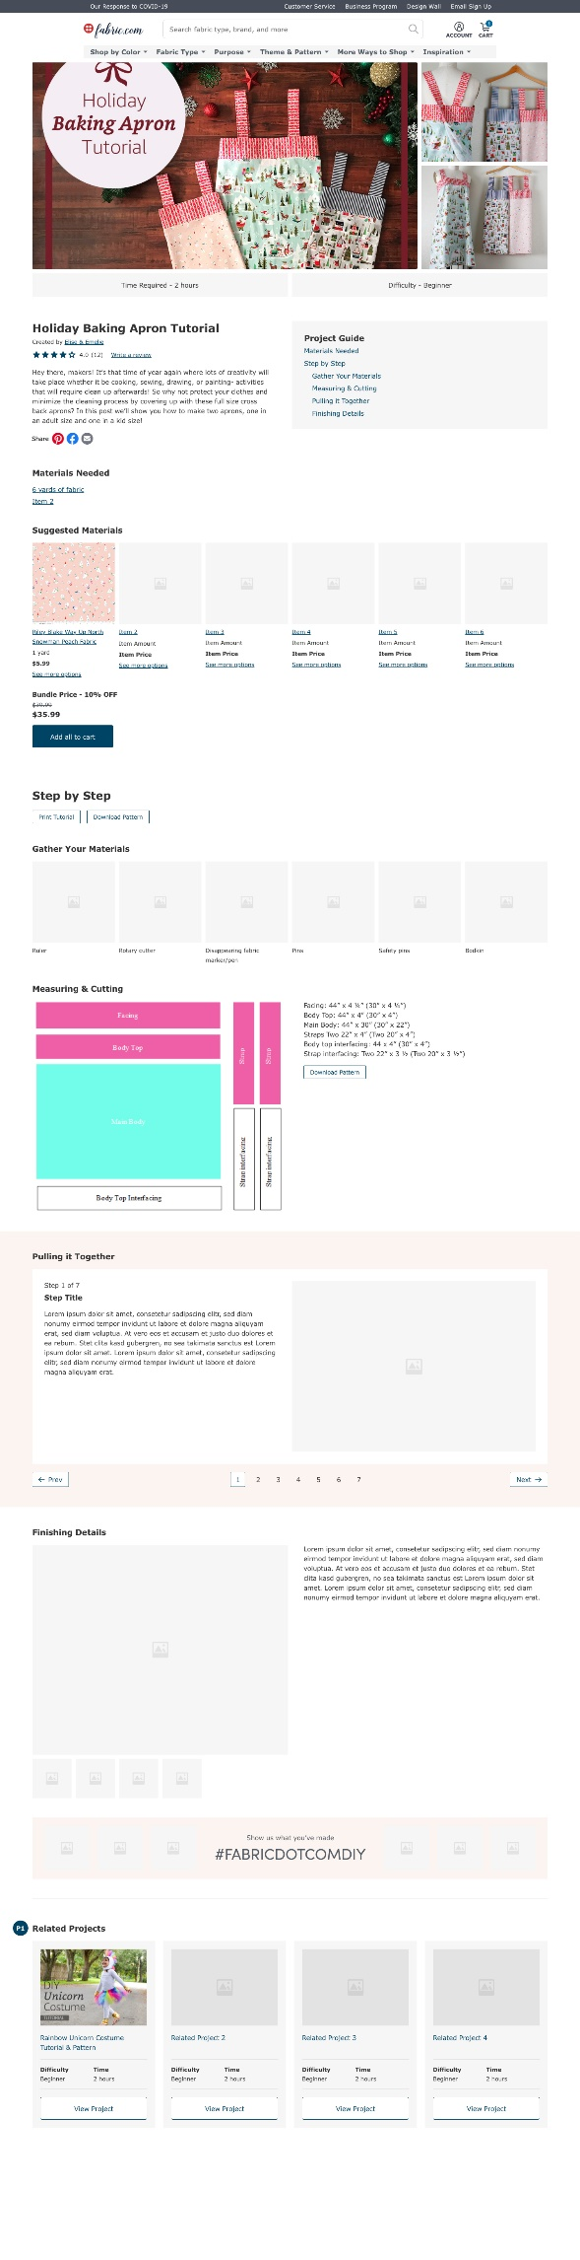

**Product Listing Page (PLP) with Link to Inspiration Listing Page (ILP):**

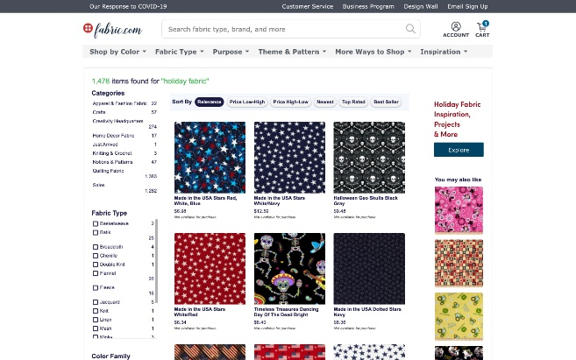

1. **ADDITIONAL PROJECT EXAMPLES**

Sewing 101 (2 types)

* How to choose <https://www.fabric.com/blog/sewhappycolor-color-theory-guide-with-katie-kortman/>
* Skills & Technique <https://www.fabric.com/blog/tips-for-sewing-swimwear/>

Inspiration

* Trend Spotlight <https://www.fabric.com/blog/sewfancypants-color-pairing-with-katie-kortman/>

Projects

* Basic DIY <https://www.fabric.com/blog/fitted-crib-sheet-tutorial/>

1. **REFERENCE BUSINESS OWNER REQUIREMENTS FROM 4/8**

<https://wiki.prd.fabric.com/download/attachments/37886078/Business%20Owner%20Requirements%204-8.docx?api=v2>

1. **ORIGINAL BRD & BUSINESS REQUIREMENTS**

<https://wiki.prd.fabric.com/download/attachments/37892934/Projects%20BRD%20012720.docx?api=v2>

<https://wiki.prd.fabric.com/download/attachments/31698699/Projects%20on%20Fabric.pptx?api=v2>